**Google analytical tool purpose and how it Will help in business requirements.**

**Tool: Google Analytics**

**Purpose:**

Google Analytics is a free web analytics service offered by Google that enables you to track and analyze website traffic. It collects data on how users interact with your site, where they come from, what devices they use, and how long they stay.

**Key Features:**

1. **Real-Time Monitoring:**
   * View active users on your site at any given moment.
   * Monitor live traffic sources, top active pages, and geographical locations.
2. **Audience Insights:**
   * Demographics (age, gender).
   * Interests and behavior patterns.
   * Devices, operating systems, and browsers used.
3. **Acquisition Reports:**
   * Understand how users arrive (e.g., organic search, paid ads, direct, referral).
   * Evaluate marketing channel effectiveness.
4. **Behavior Analysis:**
   * Track page views, bounce rates, time on site, and exit pages.
   * Identify high-performing and underperforming content.
5. **Conversion Tracking:**
   * Set up goals (e.g., purchases, sign-ups).
   * Analyze sales funnels and drop-off points.
6. **User Flow Visualization:**
   * See the paths users take through your website.
   * Discover where users typically enter, move through, and exit your site.

**UX Contribution:**

Google Analytics is a critical tool for UX professionals, offering data that directly informs design decisions. Here's how it contributes to enhancing the user experience:

**🔍 Identifying User Flows**

* Visualizes typical navigation paths.
* Helps designers optimize content hierarchy and internal linking to match user behavior.

**📉 Bounce Rate Insights**

* High bounce rates on certain pages can signal poor content relevance, slow load times, or confusing layouts.
* Allows UX teams to pinpoint problem pages and test improvements (e.g., better calls-to-action, clearer navigation).

**📈 Popular Content Recognition**

* Highlights pages and content that receive the most engagement.
* Provides clues about what users value, guiding content strategy and layout emphasis.

**⏱️ Session Duration & Engagement**

* Tracks how long users stay and what they interact with.
* Aids in evaluating the effectiveness of interactive elements and overall site usability.

**📊 Segment Analysis**

* Breaks down behavior by user type (e.g., new vs. returning, mobile vs. desktop).
* Enables personalized UX optimizations across platforms and audiences.

**Why It Matters for UX Design:**

UX decisions should be **data-driven**. Google Analytics offers quantitative evidence of how users engage with your product, enabling you to:

* Identify friction points in user journeys.
* Prioritize updates based on real user behavior.
* Justify design changes with stakeholder-facing data.
* Validate improvements via post-launch tracking.

**How Google Analytics Helps in Meeting Business Requirements**

Google Analytics supports various **business goals** by providing actionable insights. Here's how it aligns with common business needs:

**A. Improves Decision Making**

* Provides **real-time and historical data** that helps businesses make evidence-based decisions.
* Replaces assumptions with **data-backed insights**.

**B. Increases ROI on Marketing**

* Shows which campaigns, channels, or keywords are most effective.
* Helps businesses **allocate budget** more wisely across high-performing sources.
* Tracks customer journeys from **acquisition to conversion**.

**C. Enhances Customer Understanding**

* Offers insights into user demographics, interests, and behavior.
* Enables **segmentation** of users to tailor experiences or messaging for different audiences.

**D. Optimizes Website Performance**

* Identifies high bounce rates and exit pages to target for improvement.
* Helps **refine UX/UI design** to increase engagement and reduce friction.
* Supports **A/B testing** and performance comparisons after changes.

**E. Supports Goal Tracking & KPIs**

* Custom goals (e.g., purchases, downloads) allow businesses to measure success directly.
* Funnels reveal where users **drop out of processes**, helping businesses fine-tune them.

**F. Informs Product and Content Strategy**

* Reveals what content performs best and what users search for.
* Helps prioritize **product features or updates** based on usage patterns.

**3. Real-World Use Case Examples**

* **E-commerce Store:** Uses Analytics to track conversion rates, cart abandonment, and product popularity. Improves checkout flow based on drop-off data.
* **Service Company:** Identifies which blog topics generate the most leads and doubles down on similar content.
* **Startup:** Measures traffic from different marketing experiments (e.g., social media vs email) to understand what drives sign-ups.

**Conclusion**

**Google Analytics bridges the gap between business objectives and user behavior.** It empowers companies to:

* Understand their audience.
* Improve the effectiveness of digital strategies.
* Drive higher engagement, satisfaction, and ultimately revenue.

Here’s a visual example showing how you might track and analyze social media data for a **grandparents-focused online platform** using the **Google Analytics 4 lifecycle model**:

**🔍 Lifecycle Stage Breakdown (With Examples)**

| **GA4 Lifecycle Stage** | **Social Media Metric Example** | **Use Case for Grandparents Platform** |
| --- | --- | --- |
| **Acquisition** | Sessions from Facebook, Instagram | See which platforms bring in senior users (e.g., from Facebook caregiver groups) |
| **Engagement** | Engagement rate by channel | Check if users are reading articles on arthritis or retirement tips |
| **Monetization** | Conversions from social visitors | Track sign-ups for wellness kits or senior tech classes |
| **Retention** | Return visits over time | See if they return after a newsletter or social campaign |

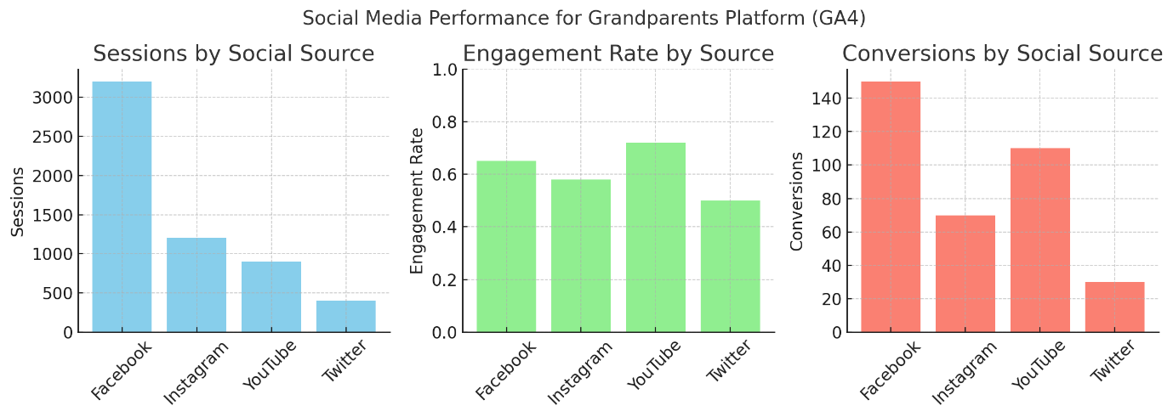

**📊 Explanation of the Graphs Above:**

1. **Sessions by Source**:
   * Facebook drives the most traffic (great for targeting senior communities).
2. **Engagement Rate**:
   * YouTube users are the most engaged — videos like “how to use a smartphone” may resonate well.
3. **Conversions**:
   * YouTube has a high conversion rate despite lower traffic — great ROI.